iOS EW202W SDK
V1.0
Author: CUI XIAODONG
2020/05/26

Modification Record
Date | Item | Person
2020-05-26 | File created | CUI XIAODONG
2020-06-18 | Document check | Shawn

内部文档 严禁外传

Contents
Modification Record 1
Contents 2
I. APP iOS SDK 5
Functions and Objectives 5
II. Development Preparation 5
1 .framework 5
2 .Development Environment Settings 5
III. API Description 7
How To Call API 7
1. SDK Initialization 7
Interface Description 7
Parameter Description 7
2. Connect BLE 8
Interface Description 8
Parameter Description 8
3. Network Configuration 9
Interface Description 9
Parameter Description 9
4. Authentication Login 10
Interface Description 10
Parameter Description 10
5. Acquire Device Information 10
Interface Description 11
Parameter Description 11
6. Initialize device, restore to factory settings 11
Interface Description 11
Parameter Description 11
7. Work status query 12
Interface Description 12
Parameter Description 12
8. Firmware upgrade 12
Interface Description 13
Parameter Description 13
9. Alarm Configuration(add, modify, delete) 13
Interface Description 13
Parameter Description 13
10. Acquire alarm list 14
Interface Description 14
Parameter Description 14
11. Alarm preview 14
Interface Description 15
Parameter Description 15
12. Light control 15
Interface Description 15
Parameter Description 16
13. Alarm music control 16
Interface Description 16
Parameter Description 17
14. Clock dormancy settings 17
Interface Description 17
Parameter Description 17
15. Acquire clock dormany 18
Interface Description 18
Parameter Description 18
16. Sleep-aid info configuration 18
Interface Description 18
Parameter Description 19
17. Acquire sleep-aid info 19
Interface Description 19
Parameter Description 19
IV. Object Description 19
Notification 20
Method 20
Description 20
SLPBLEScanReturnCodes 20
Description 20
SLPDeviceTypes 20
Description 20
SLPTransforCallback 21
Method 21
Method Description 21
Parameter Description 21
SLPDataTransferStatus 22
Description 22
SLPPeripheralInfo 22
Class Description 22
Field Description 22
SLPDeviceInfo 23
Class Description 23
Field Description 23
EW202WDeviceInfo 23
Class Description 23
Field Description 23
EW202WWorkState 24
Class Description 24
Field Description 24
SLPLTcpUpgradeInfo 25
Class Description 25
Field Description 25
EW202WAlarmInfo 25
Class Description 25
Field Description 25
EW202WAidInfo 26
Class Description 26
Field Description 27
SLPTimeInfo 27
Class Description 27
Field Description 27
SLPLight 28
Class Description 28
Field Description 28
EW202WClockDormancyBean 28
Class Description 28
Field Description 28

I. APP iOS SDK

Functions and Objectives
EW202W Android SDK is a software development toolkit launched by Sleepace, aiming to conduct fast development for Internet of Things APP on the Android platform. The SDK encapsulates the communication process between the APP and the hardware, and provides functions such as device configuration, device control, and data query. Using this SDK, users do not need to care about complex communication protocol and the underlying implementation, only need to focus on APP interactions and business levels.

II. Development Preparation

1 .framework

framework | Description
SLPCommon.framework | Common Parts
EW202W.framework | EW202W core
SLPLTCP.framework | SDK core
BLEWifiConfig.framework | BLE configuration
BluetoothManager.framework | BLE configuration related

2 .Development Environment Settings
1: Add library libc++.tbd，Add BluetoothManager.framework,SLPCommon.framework , BLEWifiConfig.framework,SLPCommon.framework,EW202W.framework into the project
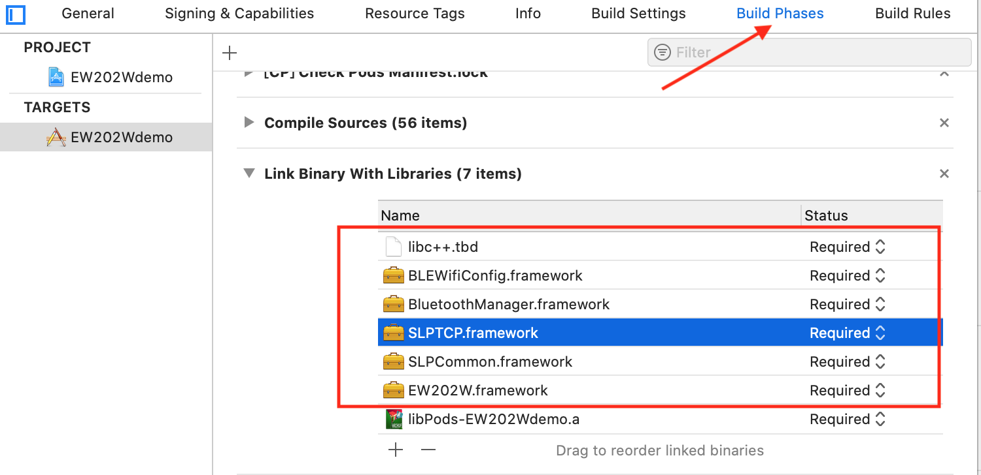

2: Since this SDK uses the third-party library AFNetworking, you need to add AFNetworking to the project. It is recommended to use CocoaPods to manage the third-party library, or you can download and import the project yourself
3: other linker flags 添加库链接add library links
-force_load $(SRCROOT)/BLENox2Demo/libs/BluetoothManager.framework/BluetoothManager
-force_load $(SRCROOT)/EW202Wdemo/libs/BLEWifiConfig.framework/BLEWifiConfig
-force_load $(SRCROOT)/EW202Wdemo/libs/SLPTCP.framework/SLPTCP
Notice: $(SRCROOT) is followed by the relative address of the library
If you use CocoaPods to manage AFNetworking, you need to add $(inherited)
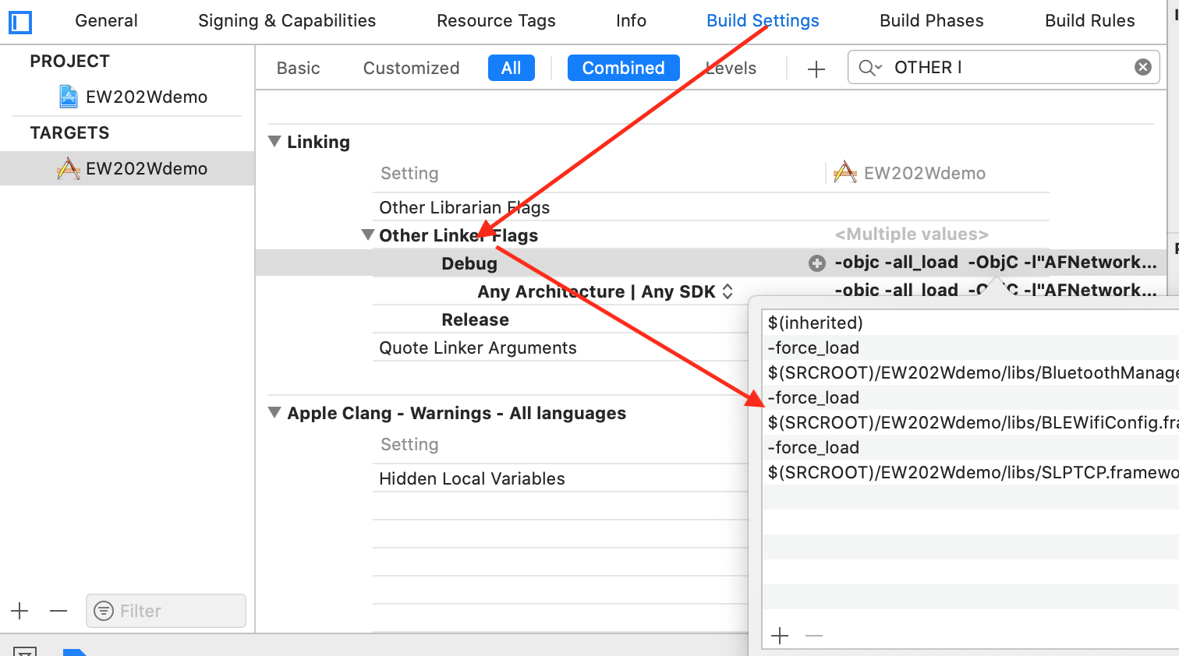

III. API Description

How to call API
You need to call the initialization interface before using the API

- network configuration related
#import <BluetoothManager/BluetoothManager.h>
[SLPBLESharedManager <方法>]

#import <BLEWifiConfig/BLEWifiConfig.h>
[SLPBleWifiConfig <方法>]

- device operation and configuration
#import <EW202W/EW202W.h>
[SLPSharedLTcpManager <方法>]

SDK Initialization
- (void)installSDKWithToken:(NSString *)token ip:(NSString *)ip
channelID:(NSInteger)channelID timeout:(CGFloat)timeoutInterval
completion:(SLPTransforCallback)handle

Interface Description
Used to initialize the SDK, the SDK can be used normally after the call

Parameter Description
Field | Type | Description
token | NSString | User token
ip | NSString | IP address
channelID | NSString | Channel ID
handle | SLPTransforCallback | Callback interface

连接蓝牙Connect BLE
- (void)connectAndGetDeviceInfoWithPeripheral:(CBPeripheral *)peripheral
deviceType:(SLPDeviceTypes)deviceType
completion:(void(^)(SLPDataTransferStatus status, id data))completion;

Interface Description
Used to connect the device Bluetooth to acquire device information

Parameter Description
Field | Type | Description
peripheralInfo | SLPPeripheralInfo | See: SLPPeripheralInfo for details
deviceType | SLPDeviceTypes | device type
status | SLPDataTransferStatus | TCP or Bluetooth request return value, see enumeration SLPDataTransferStatus for details
data | id | The callback data is valid when the status is SLPDataTransferReturnStatus_Succeed. The user must convert to a corresponding object with a different interface. For details, please see each Interface Description

Network Configuration
- (void)configPeripheral:(CBPeripheral *)peripheral deviceType:(SLPDeviceTypes)deviceType
serverAddress:(NSString *)address port:(NSInteger)port
wifiName:(NSString *)name
password:(NSString *)password
completion:(void(^)(SLPDataTransferStatus status, id data))completion;

Interface Description
Used for device network configuration

Parameter Description
Field | Type | Description
peripheralInfo | SLPPeripheralInfo | See: SLPPeripheralInfo for details
deviceType | SLPDeviceTypes | Device type
address | NSString | IP Address
port | NSInteger | IP port
name | NSString | WiFi name
password | NSString | WiFi password
status | SLPDataTransferStatus | TCP or Bluetooth request return value, see enumeration SLPDataTransferStatus for details
data | id | The callback data is valid when the status is SLPDataTransferReturnStatus_Succeed. The user must convert to a corresponding object with a different interface. For details, please see each Interface Description

Authentication Login
- (BOOL)loginDeviceID:(NSString *)deviceID completion:(SLPTransforCallback)handle;

Interface Description
-Used to connect to the login device

Parameter Description
Field | Type | Description
deviceID | NSString | Device ID
handle | SLPTransforCallback | Callback interface

Bind device
- (void)bindDevice:(NSString *)deviceID leftRight:(NSInteger)leftRight timeout:(CGFloat)timeoutInterval completion:(SLPTransforCallback)handle;

Interface Description
-used to bind device

Parameter Description
Field | Type | Description
deviceID | NSString | Device ID
leftRight | NSInteger | 0
timeoutInterval | CGFloat | time out
handle | SLPTransforCallback | Callback interface

Unbind device
- (void)unBindDevice:(NSString *)deviceID leftRight:(NSInteger)leftRight timeout:(CGFloat)timeoutInterval completion:(SLPTransforCallback)handle;

Interface Description
-Used to unbind device

Parameter Description
Field | Type | Description
deviceID | NSString | Device ID
leftRight | NSInteger | 0
timeoutInterval | CGFloat | time out
handle | SLPTransforCallback | Callback interface

Acquire device info
- (void)ew202wGetDeviceInfo:(NSString *)deviceName deviceType:(SLPDeviceTypes)deviceType timeout:(CGFloat)timeout callback:(SLPTransforCallback)handle;

Interface Description
to acquire device info

Parameter Description
Field | Type | Description
deviceName | NSString | Device name
deviceType | SLPDeviceTypes | Device type
timeout | CGFloat | timeout unit:second
handle | SLPTransforCallback | Callback interface, return object successfully data= EW202WDeviceInfo

Initialize the device and restore the factory settings
- (void)ew202wDeviceInitWithDeviceInfo:(NSString *)deviceName timeout:(CGFloat)timeout callback:(SLPTransforCallback)handle;

Interface Description
to restore to the factory settings

Parameter Description
Field | Type | Description
timeout | CGFloat | timeout unit:second
deviceName | NSString | device name
handle | SLPTransforCallback | Callback interface

Work status query
- (void)ew202wGetWorkStatusWithDeviceInfo:(NSString *)deviceName timeout:(CGFloat)timeout callback:(SLPTransforCallback)handle;

Interface Description
It is used to acquire the working status of the device. When the status of the device changes, the user can acquire the real-time status by monitoring kNotificationNameEW202WWorkModeChange.

Parameter Description
Field | Type | Description
timeout | CGFloat | timeout unit:second
deviceName | NSString | device name
handle | SLPTransforCallback | Callback interface,return object successfully data= EW202WWorkState

Firmware upgrade
- (void)ew202wPublicUpdateOperationWithDeviceID:(NSString *)deviceID deviceType:(SLPDeviceTypes)deviceType firmwareType:(UInt8)firmwareType firmwareVersion:(UInt16)version timeout:(CGFloat)timeout callback:(SLPTransforCallback)handle;

Interface Description
to operate firmware upgrade

Parameter Description
Field | Type | Description
deviceID | String | Device ID
version | UInt16 | Firmware version
deviceType | SLPDeviceTypes | Device type
firmwareType | int | Firmware type
handle | SLPTransforCallback | Callback interface

Alarm Configuration(add, modify, delete)
- (void)ew202wAlarmConfig:(EW202WAlarmInfo *)alarmInfo deviceInfo:(NSString *)deviceName timeout:(CGFloat)timeout callback:(SLPTransforCallback)handle;

Interface Description
to add, modify, delete alarm

Parameter Description
Field | Type | Description
alarmInfo | EW202WAlarmInfo | alarm info
deviceName | NSString | device name
timeout | CGFloat | timeout unit:second
handle | SLPTransforCallback | Callback interface

获取闹钟列表Acquire alarm list
- (void)ew202wGetAlarmListWithDeviceInfo:(NSString *)deviceName timeout:(CGFloat)timeout completion:(SLPTransforCallback)handle;

Interface Description
to acquire alarm list

Parameter Description
Field | Type | Description
timeout | CGFloat | timeout unit:second
deviceName | NSString | device name
handle | SLPTransforCallback | Callback interface, successfully returned object data is an array of EW202WAlarmInfo

Alarm preview
- (void)ew202wAlarmRreviewOperationVolume:(UInt8)volume brightness:(UInt8)brightness operation:(UInt8)operation musicID:(UInt16)musicID deviceInfo:(NSString *)deviceName timeout:(CGFloat)timeout callback:(SLPTransforCallback)handle;

Interface Description
to preview alarm and end preview

Parameter Description
Field | Type | Description
volume | UInt8 | Volume [0,16] 0:mute
brightness | UInt8 | Brightness[0,100] 0:no brightness
operation | UInt8 | preview operation 0:off 1:on
musicID | UInt16 | Music ID
timeout | CGFloat | timeout unit:second
deviceName | NSString | device name
handle | SLPTransforCallback | Callback interface

Light control
- (void)ew202wLightControlOperation:(UInt8)operation brightness:(UInt8)brightness lightMode:(UInt8)lightMode light:(SLPLight *)light deviceInfo:(NSString *)deviceName timeout:(CGFloat)timeout callback:(SLPTransforCallback)handle;

Interface Description
to control light, turn on light and turn off light

Color code: 0:warm white 1:cold white 2:red 3:orange 4:warm yellow 5:green 6:cyan-blue 7:blue 8:purple 9:light-cycling 0xff: color (custom color, need to assign RGBW), if it is 0-9, don't pay attention to the value of RGBW

Parameter Description
Field | Type | Description
operation | UInt8 | operation code 0:turn off light 1:turn on light 2:adjust brightness
brightness | UInt8 | Brightness[0,100] 0:no brightness
lightMode | UInt8 | color code
light | SLPLight | See: SLPlight for details
deviceName | NSString | device name
handle | SLPTransforCallback | Callback interface

Alarm music control
- (void)ew202wAlarmMusicOperation:(UInt8)operation musicID:(UInt16)musicID volume:(UInt8)volume deviceInfo:(NSString *)deviceName timeout:(CGFloat)timeout callback:(SLPTransforCallback)handle;

Interface Description
to turn on music, turn off music, set volume

Parameter Description
Field | Type | Description
operation | UInt8 | operation code 0:stop 1:play 2:adjust volume
musicID | UInt16 | Music ID
volume | UInt8 | Volume [0,16] 0:mute
timeout | CGFloat | timeout unit:second
deviceName | NSString | device name
handle | SLPTransforCallback | Callback interface

Clock dormancy settings
- (void)ew202wConfigClockDormancy:(EW202WClockDormancyBean *)clockDormancyBean deviceInfo:(NSString *)deviceName timeout:(CGFloat)timeout callback:(SLPTransforCallback)handle;

Interface Description
for clock dormancy settings

Parameter Description
Field | Type | Description
clockDormancyBean | EW202WClockDormancyBean | See: EW202WClockDormancyBean for details
deviceName | NSString | device name
handle | SLPTransforCallback | Callback interface

Acquire clock dormancy
- (void)ew202wGetClockDormancyWithDeviceInfo:(NSString *)deviceName timeout:(CGFloat)timeout callback:(SLPTransforCallback)handle;

Interface Description
to acquire clock dormancy

Parameter Description
Field | Type | Description
timeout | CGFloat | timeout unit:second
deviceName | NSString | device name
handle | SLPTransforCallback | For callback result please see: EW202WClockDormancyBean for details

Sleep-aid info configuration
- (void)ew202wConfigAidInfo:(EW202WAidInfo *)aidInfo deviceInfo:(NSString *)deviceName timeout:(CGFloat)timeout callback:(SLPTransforCallback)handle;

Interface Description
to configure sleep-aid info

Parameter Description
Field | Type | Description
aidInfo | EW202WAidInfo | See: EW202WAidInfo for details
timeout | CGFloat | timeout unit:second
deviceName | NSString | device name
handle | SLPTransforCallback | Callback interface

Acquire sleep-aid info
- (void)ew202wGetAidInfoWithDeviceInfo:(NSString *)deviceName timeOut:(CGFloat)timeout callback:(SLPTransforCallback)handle;

Interface Description
to acquire sleep-aid info

Parameter Description
Field | Type | Description
timeout | CGFloat | timeout unit:second
deviceName | NSString | device name
handle | SLPTransforCallback | Callback interface, see: EW202WAidInfo for details

IV. Object Description

Notification

Method
object: Handle of TCP device SLPLTcp*lTcp
userInfo: @{key: Content }

Description
Key | Content | Description
kNotificationNameEW202WWorkModeChanged | EW202WWorkState | device status has changed
kNotificationNameNoxUpdateRateChanged | SLPLTcpUpgradeInfo | Upgrade progress
kNotificationNameLTCPDisconnected |  | Long connection disconnected
kNotificationNameLTCPConnected |  | Long connection connected

SLPBLEScanReturnCodes

Description
Field | Value | Description
SLPBLEScanReturnCode_Normal | 0 | Successfully scanned a BLE device
SLPBLEScanReturnCode_Disable | 1 | BLE disabled
SLPBLEScanReturnCode_TimeOut | 2 | Scan timeout

SLPDeviceTypes

Description
Field | Value | Description
SLPDeviceType_EW202W | 0x35 | EW202WDevice type

SLPTransforCallback

Method
Callback on Bluetooth or TCP request

Method Description
typedef void(^SLPTransforCallback)(SLPDataTransferStatus status,id data);

Parameter Description
Field | Type | Description
status | SLPDataTransferStatus | TCP or Bluetooth request return value, see enumeration SLPDataTransferStatus for details
data | id | The callback data is valid when the status is SLPDataTransferReturnStatus_Succeed. The user must convert to a corresponding object with a different interface. For details, please see each Interface Description

SLPDataTransferStatus

Description
Field | Value | Description
SLPDataTransferStatus_Succeed | 0 | Succeed
SLPDataTransferStatus_ConnectionDisconnected | 1 | Disconnected
SLPDataTransferStatus_TimeOut | 2 | Timeout
SLPDataTransferStatus_Failed | 3 | Failed
SLPDataTransferStatus_ConnectionDisabled | 4 | Connection disabled or disconnected
SLPDataTransferStatus_ParameterError | 5 | Parameter Error

SLPPeripheralInfo

Class Description
Bluetooth scan return class

Field Description
Field | Type | Description
peripheral | CBPeripheral | Bluetooth handle
name | String | device name

SLPDeviceInfo

Class Description
The device connection interface will return

Field Description
Field | Type | Description
deviceID | String | Device ID
version | String | Device’s Firmware version

EW202WDeviceInfo

Class Description
Acquire device information interface will return

Field Description
Field | Type | Description
deviceID | String | Device ID
firmwareVersion | String | Device’s Firmware version

EW202WWorkState

Class Description
The working status of the device. Users can take the initiative to acquire, the device can also take the initiative to submit

Field Description
Field | Type | Description
mode | UInt8 | Work mode 0:normal 1: configuration
lightStatus | UInt8 | Light status 0:off 1:lighting 2:sleep-aid light 3:Custom color light 4:alarm light
brightness | UInt8 | Brightness
lightMode | UInt8 | Light mode 0:warm white 1cold white 2:red 3:orange 4:warm yellow 5:green 6:cyan-blue 7:blue 8:purple 9:light-cycling
light | SLPLight | 灯光 固定流光此项为nil  Light Fixed light-cycling This item is nil
alarmStatus | UInt8 | Alarm status 0x00:not running 0x01:running 0x02:snoozing 0x03:previewing
timeMode | UInt8 | Time format 0:12hr format 1:24hr format
pincode | UInt8 | BLE PIN switch 0:off 1:on
systemBluetooth | UInt8 | BLE switch 0:off 1:on
syncServerFlag | UInt8 | Sync server switch 0:off 1:on
asssitStaus | UInt8 | Sleep-aid status 0:stop 1:running
asssitLightStaus | UInt8 | Sleep-aid light status 0:off 1:on
assistMusicStatus | UInt8 | Sleep-aid music status 0:off 1:on
assistMusicID | UInt16 | Music ID
assistTimeRemained | UInt8 | Remained sleep-aid time
channelNum | UInt32 | Channel number 0:Local report

SLPLTcpUpgradeInfo

Class Description
After calling the firmware upgrade interface, the device will automatically report the upgrade status, and the monitoring notification kNotificationNameNoxUpdateRateChanged can be acquired.

Field Description
Field | Type | Description
rate | NSInteger | Upgrade progress (progress 0-100%)

EW202WAlarmInfo

Class Description
Alarm info, add (modify) the parameter type of the alarm interface

Field Description
Field | Type | Description
alarmID | UInt64 | Alarm ID, Unique ID, generally provided by server
isOpen | BOOL | Alarm Switch
hour | UInt8 | Hour
minute | UInt8 | Minute
flag | UInt8 | repeat  Monday-Sunday switch (0-6 position) 0: off, 1: on  All 0 means single alarm, set timestamp as expiration standard
snoozeTime | UInt8 | Snooze Time
snoozeLength | UInt8 | Snooze Length
volume | UInt8 | Volume 0-16
brightness | UInt8 | Brightness 0-100
musicID | UInt16 | Music ID
timestamp | UInt32 | Timestamp, set / modify the standard timestamp when alarm is used (for single alarm)
enable | UInt8 | 是否有效 0表示该闹钟已经删除 1该闹钟有效 ，删除闹钟使用该接口，将该字段设置为0  Whether it is valid 0 means the alarm has been deleted 1 the alarm is valid, use this interface to delete the alarm, set this field to 0

EW202WAidInfo

Class Description
Save the parameter type of the sleep-aid info interface

Field Description
Field | Type | Description
musicFlag | UInt8 | 音乐开关
musicID | UInt16 | Music ID
volume | UInt8 | Volume Volume(0-16) 0:Mute
musicMode | UInt8 | Loop mode 0:List play 1:Single loop
lightFlag | UInt8 | Light switch
brightness | UInt8 | Brightness (0-100)
r | UInt8 | Light Color r Component 0-255
g | UInt8 | Light Color g Component 0-255
b | UInt8 | Light Color b Component 0-255
w | UInt8 | Light Color W Component 0-255 (current W component is 0)
smartStopFlag | UInt8 | Whether to turn on smart sleep-aid
aidStopDuration | UInt16 | Sleep-aid stop time, unit: minutes

SLPTimeInfo

Class Description
Timezone, parameter type of time calibration interface

Field Description
Field | Type | Description
timestamp | UInt32 | Timestamp
timezone | int32_t | Timezone
season | UInt8 | Special Season 0: None, 1: Daylight Saving Time, 2: Winter Time
offset | int32_t | Special seasonal offset  Offset information, unit: second
timeMode | UInt8 | 12:12hr format 24:24hr format

SLPLight

Class Description
Light Information

Field Description
Field | Type | Description
r | UInt8 | Light Color r Component 0-255
g | UInt8_t | Light Color g Component 0-255
b | UInt8 | Light Color b Component 0-255
w | UInt8 | Light Color w Component 0-255

EW202WClockDormancyBean

Class Description
闹钟休眠结构Alarm dormancy structure

Field Description
Field | Type | Description
flag | int | Alarm dormancy switch 0: off 1: on
startHour | int | Alarm dormancy start time: hour
startMin | int | Alarm dormancy start time: minute
endHour | int | Alarm dormancy end time: hour
endMin | int | Alarm dormancy end time: minute

